INDUSTRIAL AND COMMERCIAL BANK OF CHINA
Financial Institution Department — Credit Rating & Credit Limit Application Report
Dubai Islamic Bank PJSC
(“Borrower”, “DIB” or “the Bank”)
Counterparty Credit Assessment | March 2026 | Audited FY2025 basis | USD/AED = 3.6725

1. Overall Evaluation of Customer

1.1 Key Information List of Customer
Name of Customer | Dubai Islamic Bank PJSC (“DIB”) | Total Assets (Dec 2025) | AED 415.9 billion (≈ USD 113.3 bn)
Top / Controlling Shareholder | Investment Corporation of Dubai – ICD (≈ 28.0%) | Total Equity (Dec 2025) | AED 53.14 billion
Ultimate Shareholder | Government of Dubai | Country of Incorporation | UAE (Emirate of Dubai)
Credit Ratings | Moody’s: A3 / Stable | Fitch: A / Stable | IIRA: A+ (intl) / Stable | Auditor | KPMG Lower Gulf Limited (FY2025)
USD/AED = 3.6725
Dubai Islamic Bank PJSC (“DIB” or “the Bank”) was incorporated by Amiri Decree on 12 March 1975 in the Emirate of Dubai and is widely recognised as the world’s first full-service Islamic bank. Listed on the Dubai Financial Market (Ticker: DIB) since March 2000, the Bank is the largest Islamic bank in the UAE and the fourth-largest bank in the country overall, holding approximately 8% of total UAE banking-sector assets, c.10% of net financing and c.9% of deposits. The registered head office is at P.O. Box 1080, Al Maktoum Road, Deira, Dubai, UAE.
DIB offers a full range of Shari’ah-compliant retail, business, corporate, treasury and investment-banking products under the guidance of its Internal Shari’ah Supervision Committee and the Higher Shari’ah Authority of the CBUAE. The Bank operates an international footprint spanning Pakistan (Dubai Islamic Bank Pakistan), Indonesia (Panin Dubai Syariah Bank), Sudan (Bank of Khartoum), Kenya (DIB Bank Kenya), Bosnia (Bosna Bank International) and Türkiye (25% in the T.O.M. digital-banking group). The four principal business lines are summarised below.
Consumer Banking
- Serves over 1.6 million UAE customers with home finance, auto finance, personal finance, cards and deposits. In FY2025 consumer assets grew 22% YoY to AED 77 billion on record new financing origination of AED 37 billion (+90% YoY); segment revenue rose 10% to AED 4.9 billion. The Home Finance franchise remained the lead product, supported by a strategic tie-up with Mohammed Bin Rashid Housing Establishment (MBRHE).
Local & Cross-Border Wholesale Banking
- Provides corporate finance, trade finance, structured and sovereign financing to large corporates, GREs and institutions. The portfolio rose 24% YoY to AED 185 billion on AED 67 billion of new gross corporate financing, with cross-border assets up more than 83% YoY. The DCM franchise grew volumes by over 50% YoY to USD 57 billion.
Treasury & Sukuk
- Manages liquidity, the c.AED 91 billion Sukuk investment book (77% high-quality sovereign / FI), FX, profit-rate and proprietary positions, and acts as product provider to other segments. The Sukuk book grew 10% YoY supported by AED 20 billion of new investments.
Investment Banking & Subsidiaries
- DIB leads Islamic capital-markets origination (sovereign and corporate Sukuk across Pakistan, Egypt, Türkiye and the GCC) and holds subsidiaries including DIB Pakistan, Bank of Khartoum, DIB Bank Kenya, Deyaar Development (real estate) and Dar Al Sharia (Shari’ah advisory).
Shareholder Structure
The Government of Dubai, through the Investment Corporation of Dubai (ICD) — the principal investment arm of the Government of Dubai — holds approximately 28% of DIB’s share capital, making it the controlling and ultimate shareholder. The remainder is free-float, held by UAE and international institutional and retail investors. The Government linkage is a key rating driver, with Moody’s and Fitch both attributing several notches of ratings uplift to a very high likelihood of state support.

1.2 Board of Directors and Senior Management
The Board (2023–2026 term) comprises 14 non-executive members chaired by H.E. Mohammed Ibrahim Al Shaibani, Director-General of His Highness The Ruler’s Court of Dubai and Managing Director of ICD. The Group Chief Executive Officer is Dr. Adnan Chilwan. The Board combines public-sector governance, sovereign-investment and international banking expertise.
Name | Type | Background / External Roles
H.E. Mohammed Ibrahim Al Shaibani | Chairman – Non-Exec., Non-Indep. | DG of H.H. The Ruler’s Court of Dubai; Managing Director of ICD; Vice-Chair, Supreme Fiscal Committee of Dubai; Chairman, Dubai Healthcare City Authority.
Eng. Yahya Saeed Ahmad Nasser Lootah | Vice-Chairman – Non-Exec., Indep. | Chairman, S.S. Lootah Group; former board member, Dubai Chamber of Commerce.
H.E. Hamad Mubarak Buamim | Non-Exec., Indep. | Chairman, DMCC; former President & CEO, Dubai Chamber (2006–22); former CBUAE board member.
Mr. Hamad Abdulla Rashed Obaid Al Shamsi | Non-Exec., Non-Indep. | Chairman, Amanat Holding PJSC; former CEO, International Capital Trading; ex-ADIA.
Mr. Abdulaziz Ahmed Rahma Al Mheiri | Non-Exec., Non-Indep. | Chairman, Bosna Bank International supervisory board; former MD of ICD; former CEO, Dubai Bank.
Mr. Ahmad Mohammad Bin Humaidan | Non-Exec., Non-Indep. | Deputy DG, H.H. The Ruler’s Court; Vice-Chairman, Smart Dubai; former DG, Dubai Smart Government.
Mr. Javier Marin Romano | Non-Exec., Indep. | CEO, Singular Bank (Spain); former CEO, Banco Santander.
Dr. Jehad El-Nakla | Non-Exec., Indep. | 35 yrs in financial services; former GM, Moody’s Middle East (DIFC); credit & risk specialist; Chairman, Al Baraka Bank (Pakistan).
Mr. Ahmed Khalifa Al Qubaisi | Non-Exec., Indep. | Senior Executive, Group Finance & Investment, ADNOC; Certified Corporate Director (HBS).
Other independent directors | Non-Exec., Indep. | Mr. Abdulla Hamad Rahma Al Shamsi; Mr. Bader Hareb; Mr. Majid Bin Dalmook Al Falasi; Mr. Yusef bin Saeed Lootah; Dr. Cigdem Kogar (former CBRT executive).

2. Evaluation and Financial Position

2.1 Financial Situation
DIB’s consolidated financial statements were audited by KPMG Lower Gulf Limited for FY2025 (unmodified opinion, IFRS) and by Deloitte & Touche (M.E.) for FY2023 and FY2024 (unmodified opinions). The three complete primary statements — statement of financial position, statement of profit or loss and statement of cash flows — are set out below for FY2023–FY2025 (AED million); the latest interim (Q1 2026) position is summarised in section 2.3.
Consolidated Statement of Financial Position (as at 31 December)
AED million | FY2023 | FY2024 | FY2025 | YoY%
ASSETS
Islamic financing & investing assets, net | 199,453 | 212,000 | 262,055 | +23.6%
Investments in Sukuk | 68,172 | 82,600 | 90,589 | +9.7%
Cash, interbank placements & other assets | 46,667 | 50,087 | 63,304 | +26.4%
Total assets | 314,292 | 344,687 | 415,948 | +20.7%
LIABILITIES
Customers’ deposits | 222,054 | 248,510 | 320,184 | +28.8%
Due to banks, Sukuk issued, payables & other | 44,803 | 43,324 | 42,629 | −1.6%
Total liabilities | 266,857 | 291,834 | 362,813 | +24.3%
EQUITY
Share capital | 7,241 | 7,241 | 7,241 | 0.0%
Tier 1 Sukuk | 8,264 | 10,101 | 7,346 | −27.3%
Other reserves & treasury shares | 14,785 | 15,875 | 16,477 | +3.8%
Investments fair value reserve | (1,332) | (1,267) | (1,197) | −5.5%
Exchange translation reserve | (1,741) | (2,029) | (2,371) | +16.9%
Retained earnings | 17,341 | 19,904 | 22,412 | +12.6%
Equity attributable to owners | 44,557 | 49,825 | 49,908 | +0.2%
Non-controlling interests | 2,877 | 3,028 | 3,228 | +6.6%
Total equity | 47,434 | 52,853 | 53,135 | +0.5%
Total liabilities & equity | 314,292 | 344,687 | 415,948 | +20.7%
FY2023 and FY2025 reflect audited line items in full (FY2025 per the audited 31-Dec-2025 comparative in the Q1 2026 interim statements); all equity components and balance-sheet totals are audited for all three years. For FY2024, total assets (AED 344,687m, per published statements) and equity are audited; customers’ deposits are derived and the remaining asset/liability items are grouped to reconcile to the audited totals. YoY% is FY2025 vs FY2024.
Consolidated Statement of Profit or Loss (year ended 31 December)
AED million | FY2023 | FY2024 | FY2025 | YoY%
Income from Islamic financing & investing | 17,227 | 19,454 | 19,548 | +0.5%
Commissions, fees & FX income | 1,795 | 1,748 | 1,874 | +7.2%
Income from other investments at FV, net | 31 | 17 | 28 | +64.7%
Income from properties for development & sale | 237 | 342 | 487 | +42.4%
Income from investment properties | 344 | 739 | 505 | −31.7%
Share of profit from associates & JV | 215 | 485 | 381 | −21.4%
Other income | 294 | 556 | 1,004 | +80.6%
Total income | 20,142 | 23,341 | 23,827 | +2.1%
Depositors’ & Sukuk-holders’ share of profit | (8,477) | (10,505) | (10,576) | +0.7%
Net income (net operating revenue) | 11,665 | 12,837 | 13,251 | +3.2%
Personnel expenses | (1,724) | (1,989) | (2,257) | +13.5%
General & administrative expenses | (1,232) | (1,181) | (1,251) | +5.9%
Depreciation – investment properties & PPE | (206) | (255) | (255) | +0.2%
Total operating expenses | (3,162) | (3,425) | (3,763) | +9.9%
Net operating income before impairment | 8,503 | 9,412 | 9,488 | +0.8%
Impairment charges, net | (1,396) | (407) | (485) | +19.2%
Profit before income tax | 7,108 | 9,005 | 9,003 | −0.0%
Income tax expense | (98) | (840) | (1,195) | +42.3%
Net profit for the year | 7,010 | 8,165 | 7,808 | −4.4%
– Attributable to owners of the Bank | 6,798 | 7,934 | 7,500 | −5.5%
– Non-controlling interests | 212 | 231 | 307 | +32.9%
Earnings per share (AED) | 0.88 | 1.04 | 0.98 | −5.8%
Audited consolidated statement of profit or loss (AED ’000 rounded to AED million). YoY% is FY2025 vs FY2024.
Consolidated Statement of Cash Flows (year ended 31 December)
AED million | FY2023 | FY2024 | FY2025 | YoY%
Profit before income tax | 7,108 | 9,005 | 9,003 | −0.0%
Operating cash flow before working-capital changes | 8,074 | 8,431 | 8,577 | +1.7%
Net cash from operating activities | 20,156 | 15,260 | 12,983 | −14.9%
Net cash used in investing activities | (16,005) | (12,688) | (7,777) | −38.7%
Net cash (used in) / from financing activities | (4,409) | 1,262 | (6,206) | n.m.
Net (decrease) / increase in cash | (258) | 3,834 | (999) | n.m.
Cash & cash equivalents, end of period | 26,614 | 32,343 | 31,300 | −3.2%
Audited consolidated statement of cash flows (summary). The FY2023 closing balance (AED 26.6bn) and the FY2024 opening balance (AED 28.5bn) differ owing to a subsequent refinement in the definition of cash and cash equivalents. YoY% is FY2025 vs FY2024.

2.2 Financial Performance in 2025
Key Financial Highlights – FY2025 (from the Bank’s results release)
- Total Assets reached AED 416 billion, up a record 21% YoY — the strongest balance-sheet growth in years, well above the c.18% UAE sector average.
- Operating revenue reached AED 13.3 billion (+3% YoY); pre-tax profit grew 20% to AED 9.0 billion on a normalised prior-year basis (the prior-year reported figure included large one-off provision releases). Reported net profit, after the higher full-year corporate-tax charge, was AED 7.81 billion.
- Net financing assets rose 23% to AED 262 billion and the Sukuk book grew 10% to AED 91 billion; combined financing & Sukuk reached AED 353 billion (+20%).
- Customer deposits surged 29% to AED 320 billion, with CASA up 17% to AED 110 billion — a structurally low-cost funding base.
- Asset quality reached a multi-year best: NPF ratio improved 135 bps to 2.65%, cost of risk just 14 bps, cash coverage 120% and total coverage 160%.
- Capital and liquidity remained sound: CET1 12.3%, Tier 1 14.8%, CAR 15.5%, LCR 157%, NSFR 109%. A proposed dividend of 35 fils/share was approved (AED 2.53 billion).
Income statement
FY2025 net operating revenue rose 3% to AED 13.25 billion and pre-impairment operating profit reached AED 9.49 billion. Reported pre-tax profit held at AED 9.0 billion (up 20% on a normalised prior-year basis, the prior year having benefited from large one-off provision releases). Revenue quality improved, with non-funded income at c.AED 4.3 billion; the cost-to-income ratio was contained at 28.4% and impairment charges stayed low at AED 485 million. Reported net profit eased to AED 7.81 billion on a higher full-year corporate-tax charge of AED 1.20 billion. Full line-item detail is in the statement of profit or loss in section 2.1.
Balance sheet
The balance sheet expanded 21% to AED 416 billion, the fastest pace in years, driven by broad-based growth across consumer, local-corporate and cross-border businesses (AED 124 billion of new gross financing & Sukuk, +80% YoY). Funding kept pace, with deposits up 29% to AED 320 billion materially outpacing financing growth and reinforcing an already strong liquidity position. Total equity rose modestly to AED 53.1 billion after a AED 2.75 billion Tier 1 Sukuk redemption and dividend distribution, with retained earnings climbing to AED 22.4 billion.
Cash flows
Operating cash generation remained strong in FY2025. Net cash from operating activities was AED 13.0 billion, driven by AED 8.6 billion of pre-working-capital operating cash flow and a very large customer-deposit inflow that funded the increase in financing assets. Net cash used in investing was AED 7.8 billion (mainly net Sukuk additions), and financing activities used AED 6.2 billion (Tier 1 Sukuk redemption, Sukuk repayment, dividends and Zakat). Period-end cash and cash equivalents stood at AED 31.3 billion. The bank does not separately disclose an interim cash-flow statement for Q1 2026; liquidity nonetheless remained strong through the quarter (LCR 121%, NSFR 106%).

2.3 Financial Performance in Q1 2026
Q1 2026 was the first reporting period to fall within the Iran-war environment that began in late February 2026. DIB delivered a resilient start: operating revenue rose 13% YoY to AED 3.55 billion and operating profit 12% to AED 2.55 billion, though bottom-line growth was capped by a lower profit-rate environment and a deliberately more cautious provisioning stance.
- Pre-tax profit of AED 2.13 billion (+1% YoY) and net profit of AED 1.80 billion (broadly flat vs Q1 2025’s AED 1.80 billion); pre-tax RoTE of 21%.
- Revenue mix strengthened: non-funded income surged 30% YoY to AED 1.25 billion and funded income rose 5% to AED 2.30 billion; cost-to-income held at 28.2%.
- Total assets reached AED 419.9 billion (≈ AED 420 billion); net financing & Sukuk investments grew 3% YTD to AED 364 billion; customer deposits rose to AED 322 billion (+1% YTD), with current & savings (CASA) balances up c.AED 4 billion even as higher-cost term deposits were allowed to run off.
- Asset quality improved further: NPF ratio down 14 bps YTD to 2.5%. Net profit margin narrowed c.40 bps to 2.5% on lower rates, and the bank increased provisioning amid softer recoveries — a prudent response to the regional environment.
- Capital and liquidity stayed sound: CET1 12.6%, CAR 15.8%, LCR 121% and NSFR 106% — all comfortably above regulatory minima.

2.4 KPIs Summary
 | Item | 2023 | 2024 | 2025 | Q1 2026
Profitability | Pre-tax profit (AED bn) | 7.1 | 9.0 | 9.0 | 2.1
 | Net profit – group (AED bn) | 7.0 | 8.17 | 7.81 | 1.80
 | Net profit margin | 3.1% | 3.0% | 2.7% | 2.5%
 | Cost-to-income | 27.1% | 26.7% | 28.4% | 28.2%
Credit Quality | NPF ratio | 5.4% | 4.0% | 2.65% | 2.5%
Capital & Liquidity | CET1 ratio | 12.8% | 13.2% | 12.3% | 12.6%
 | Capital adequacy ratio | 17.3% | 18.3% | 15.5% | 15.8%
 | Liquidity Coverage Ratio (LCR) | 188.7% | 159.4% | 157.0% | 121.0%
FY2023–FY2025 are audited full years; Q1 2026 is an unaudited 3-month interim (profit figures are quarterly, not annualised). NSFR was 109% at FY2025 and 106% at Q1 2026 (minimum 100%); post-tax RoTE was 20% / 22% / 18% across FY2023–FY2025 and pre-tax RoTE was 21% in Q1 2026.
The trajectory shows materially stronger asset quality — NPF down from 5.4% (2023) to 2.65% (2025) and further to 2.5% at Q1 2026 — alongside record balance-sheet scale (assets AED 420 billion). Profitability remains robust: FY2025 pre-tax profit of AED 9.0 billion grew 20% on a normalised basis, and Q1 2026 sustained pre-tax profit of AED 2.1 billion despite a lower profit-rate environment. Post-tax returns reflect the full-year UAE corporate-tax charge rather than operational weakening.
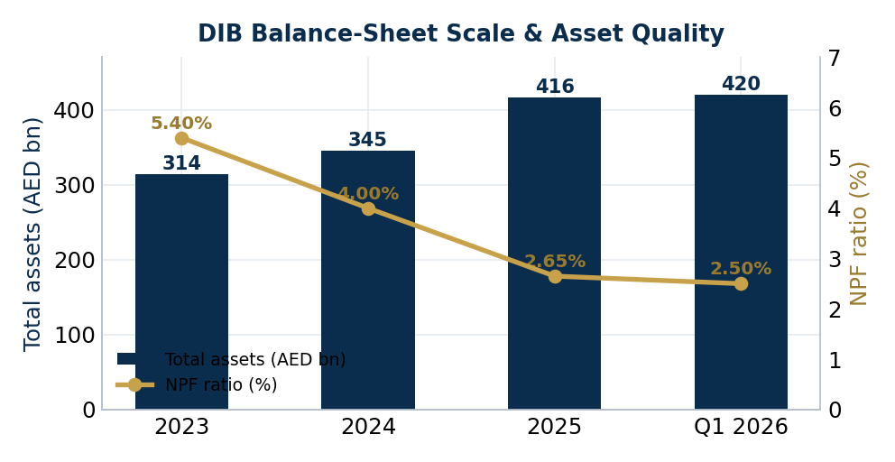
Peer Comparison — Top UAE Banks (FY2025 / latest available)
DIB is benchmarked against the three largest UAE banks by assets — First Abu Dhabi Bank (FAB), Emirates NBD (ENBD) and Abu Dhabi Commercial Bank (ADCB). All three are substantially larger, conventional (non-Islamic) institutions; DIB ranks fourth nationally and is the largest Islamic bank.
Item | FAB | Emirates NBD | ADCB | DIB
Rank by total assets | 1 | 2 | 3 | 4
Total assets (AED bn) | ~1,400 | ~1,050 | ~720 | 416
Net profit after tax (AED bn) | ~21 | ~23.4 | ~11 | 7.8
Net interest / profit margin | 1.84% | ~3.4% | ~2.8% | 2.7%
Cost-to-income | ~22% | ~30% | ~33% | 28.4%
ROE / RoTE | ~20% | ~17.7% | ~15% | 18%
NPL / NPF ratio | ~2.5% | 2.8% | 1.9% | 2.65%
CET1 ratio | 13.4% | 14.3% | 13.4% | 12.3%
Capital adequacy ratio | ~15% | 16.6% | ~16% | 15.5%
Peer figures are FY2025 or latest available (some 9M’25 / annualised) and rounded; FAB and ADCB net-profit and certain ratios are estimates pending final FY2025 disclosures. DIB’s “margin” is its Islamic net profit margin, not directly comparable to conventional NIM.
DIB compares favourably on asset quality (NPF 2.65% vs ENBD 2.8%) and operating efficiency relative to ENBD/ADCB, while its CET1 (12.3%) sits at the lower end of the peer set — a point flagged by Fitch as a constraint on the standalone profile. The large conventional peers benefit from greater scale, lower funding-cost-driven margins (FAB) and stronger headline capital. Overall, DIB’s profile — a dominant Islamic franchise, sharply improving asset quality, strong liquidity and a high likelihood of sovereign support — makes it a sound and improving counterparty.

3. Risk Analysis

3.1 Macro Business Environment — UAE / Dubai
The UAE's macro outlook has shifted materially since the outbreak of the Iran war in early 2026. In its most recent sovereign review (23 May 2026), Fitch affirmed the UAE at ‘AA-’ with a Stable Outlook, but now projects real GDP to contract by 4.8% in 2026 — a sharp reversal from the c.4–5% growth recorded through 2025 — with non-oil GDP shrinking 3.2% and Dubai's GDP falling close to 7%. Hydrocarbon GDP is expected to decline c.10% in 2026 before rebounding strongly in 2027 as production is no longer constrained by OPEC+ quotas. Fitch expects a gradual re-opening of the Strait of Hormuz from July 2026, though the course of the war remains highly uncertain.
Crucially, the sovereign's buffers remain exceptional and underpin the affirmed rating. Abu Dhabi's sovereign net foreign assets are estimated at 164% of UAE GDP — among the highest of Fitch-rated sovereigns — and the consolidated budget is expected to stay in surplus at c.4.5% of GDP in 2026 despite a near-20% rise in spending on war-mitigation and recovery programmes. Resilient hydrocarbon revenue (oil averaging c.USD 87/bbl in 2026, with exports re-routed via the Fujairah pipeline) largely offsets the immediate disruption. Consolidated government debt is forecast to rise moderately to 27% of GDP (from 24.3% at end-2025), and the current-account surplus is projected to narrow sharply to 1.3% of GDP (from 10.6% in 2025), while CBUAE FX reserves eased c.9% to USD 277 billion by March 2026. The USD/AED peg (3.6725) remains well-anchored by these buffers. S&P (AA/A-1+, Stable) similarly affirmed the UAE in March 2026, citing a government consolidated net asset position of c.184% of GDP.
For Dubai — DIB's home market — Fitch expects real GDP to remain below its 2025 level even in 2027, as investment is delayed and tourism and expatriate inflows return only gradually. This tempers the previous D33-driven growth narrative and is the key swing factor for near-term consumer lending, real-estate and trade-flow volumes underpinning DIB's franchise. The principal downside risk is a renewed flare-up or a prolonged closure of the Strait of Hormuz, which would weigh further on growth and public finances.
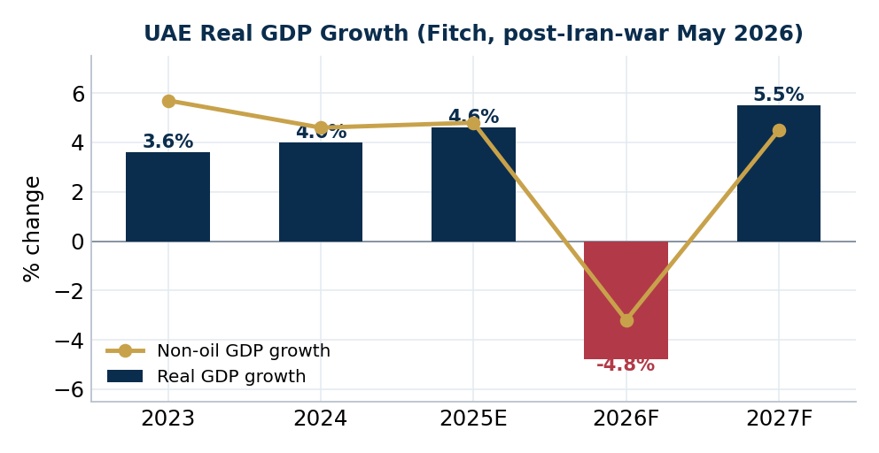

3.2 Banking Sector Outlook — UAE
UAE banks entered the Iran war from a position of strength, having grown sector assets to around AED 5.3 trillion through 2025 (c.14–17% growth) with credit expanding c.18%, supported by government spending, retail demand and cross-border corporate lending. Fitch's assessment is that UAE banks appear resilient under its base case for the war, reflecting sound financial metrics and ample liquidity and capital buffers. The war does, however, introduce a clear downside skew: under an adverse scenario in which the conflict has severe and prolonged effects, banks' Viability Ratings could face pressure from asset-quality deterioration, with real-estate lending the most likely source of stress. This sits behind Moody's earlier (pre-war) move to a Positive system outlook and frames the sector as fundamentally sound but now navigating heightened geopolitical risk.
- Asset quality improving: sector gross NPLs fell to c.3.6% by September 2025 from a 2021 peak of c.6.1%, supported by strong recoveries and a shift toward secured lending.
- Margins & rates: the rate path is now clouded by war-driven uncertainty; profitability is supported by entrenched low-cost deposit franchises, though provisioning needs could rise if the conflict escalates.
- Strong funding & liquidity: core deposit franchises dominate; sector LCR was c.149% and NSFR c.111% (Sep-2025), with limited reliance on external funding — a key shock absorber during the conflict.
- Key risk — real estate: Fitch identifies real-estate lending as the most likely source of stress under an adverse war scenario, given Dubai's projected GDP contraction and delayed investment.
- Structural tailwinds: Islamic finance continues to gain share, and the UAE’s Digital Dirham (CBDC) pilot, open-banking and digital-asset frameworks are reshaping competition while established franchises remain entrenched.
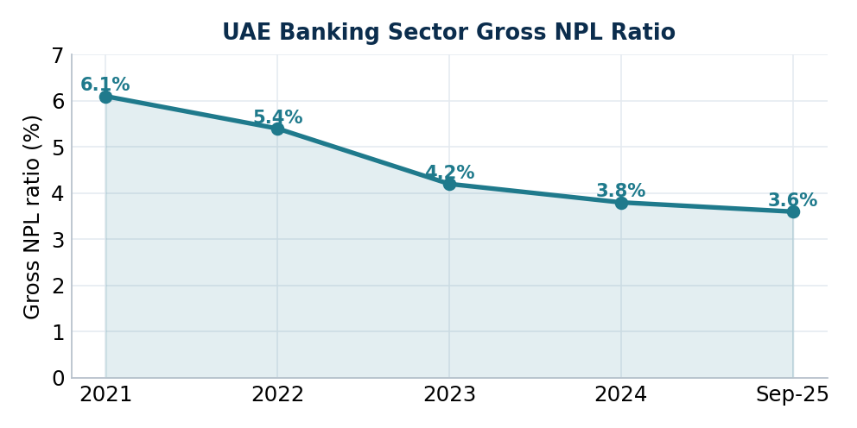

3.3 Company Risk Management
Risk is managed under a three-lines-of-defence model overseen by the Board Risk Committee, with an independent risk function consistent with CBUAE guidance. The Bank manages credit, market, profit-rate, liquidity, operational and Shari’ah-compliance risks within Board-approved appetite and an annual ICAAP stress-testing exercise.
Credit Risk
Credit risk is the Bank’s most material exposure. The financing book is well diversified across consumer (AED 77 billion), local and cross-border wholesale (AED 185 billion) and a high-quality Sukuk investment portfolio (AED 91 billion, 77% sovereign / FI). Corporate exposures span utilities, oil & gas, aviation, manufacturing, financial institutions, services and real estate; real-estate concentration, historically a legacy issue, has reduced as the portfolio mix shifted toward secured and higher-quality assets. Asset quality has improved structurally — NPF down from 5.4% (2023) to 2.65% (2025), cost of risk of just 14 bps, cash coverage of 120% and total coverage of 160%. Fitch notes that relatively high single-name concentration and reliance on hard (real-estate) collateral for provisioning are the principal residual credit considerations.
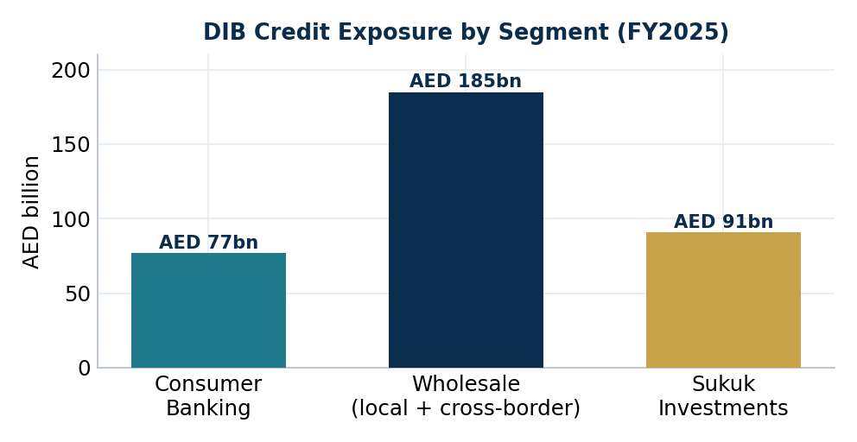
Market Risk
Market risk arises from profit-rate, FX and equity/Sukuk price exposures and is governed by the Asset & Liability Committee (ALCO) and Market Risk function within Board-approved limits. The USD/AED peg substantially eliminates bilateral FX risk on USD-denominated exposures. Trading positions are modest; the investment Sukuk portfolio is managed under an approved investment policy and is weighted toward high-grade sovereign and FI names.
Profit-Rate Risk in the Banking Book
As an Islamic bank, DIB manages profit-rate risk (the Shari’ah-compliant equivalent of interest-rate risk) through re-pricing gap analysis and net-profit-margin / economic-value sensitivity under its Enterprise Risk Management policy. With the rate path now clouded by war-driven uncertainty, the net profit margin (2.7% in 2025) is exposed to two-sided risk; however, DIB’s large, low-cost CASA base (AED 110 billion, c.34% of deposits) provides a structural buffer through asymmetric deposit re-pricing.
Liquidity Risk
Liquidity risk is managed under CBUAE requirements and ALCO oversight. DIB relies primarily on a granular, relationship-based retail and corporate deposit franchise, supplemented opportunistically by Sukuk issuance (typically >3-year tenor) and short-term interbank funding. A portfolio of high-quality liquid assets — central-bank balances, CBUAE certificates and high-grade Sukuk — backs the liquidity position. As a larger Basel III bank, DIB monitors the Liquidity Coverage Ratio (LCR) and Net Stable Funding Ratio (NSFR) rather than ELAR/ASRR; the LCR (157% at FY2025, 121% at Q1 2026) and NSFR (109% at FY2025, 106% at Q1 2026) comfortably exceed the 100% regulatory minima.
Ratio (CBUAE / Basel III) | 2023 | 2024 | 2025 | Q1 2026
Liquidity Coverage Ratio (LCR) | 188.7% | 159.4% | 157.0% | 121.0%
Source: DIB CBUAE-regulated liquidity disclosures. CBUAE minimum: LCR ≥ 100%. The Net Stable Funding Ratio (NSFR) was 109% at FY2025 and 106% at Q1 2026, above the 100% minimum. As a larger Basel III bank, DIB monitors LCR/NSFR rather than the ELAR/ASRR ratios used by smaller UAE banks. The lower Q1 2026 LCR (still well above the minimum) reflects strong financing deployment and normal quarter-end positioning.

4. Internal and External Rating of DIB

4.1 Credit Rating Review
DIB carries strong investment-grade external ratings, each on a Stable outlook, with several notches of uplift attributable to a very high likelihood of UAE / Dubai government support. Fitch rates DIB ‘A’ (Long-Term IDR) with a ‘F1’ Short-Term IDR; Moody’s rates DIB ‘A3’; and the Islamic International Rating Agency (IIRA) assigns ‘A+’ on the international scale.
Rating Agency | Rating / Outlook
Moody’s | A3 / Stable (LT issuer); affirmed Apr-2025
Fitch | A / Stable (LT IDR); F1 (ST IDR)
IIRA (Islamic International Rating Agency) | A+ (international) / A (national), Stable
Internally, DIB’s GCMS-derived rating is consistent with its A3 / A external profile, mapping to an internal rank of approximately AAA / sAA+ — one to two notches above the AA+ rank applied to comparable Baa1 / BBB+ counterparties. The internal rating should be confirmed in the GCMS system at the point of approval.

4.2 Credit Limit Availability
The proposed and outstanding ICBC credit lines for DIB are summarised below. Figures are to be completed from FID / GCMS records (placeholders shown).
USD million | Max credit line | Non-specific | Interbank ≤1yr | Interbank >1yr | Debt invest. | Underwriting | Derivatives
Current Outstanding | [ TBD ] | [ TBD ] | [ TBD ] | [ TBD ] | [ TBD ] | [ TBD ] | [ TBD ]
Current Limit | [ TBD ] | [ TBD ] | [ TBD ] | [ TBD ] | [ TBD ] | [ TBD ] | [ TBD ]
Recommended Limit | [ TBD ] | [ TBD ] | [ TBD ] | [ TBD ] | [ TBD ] | [ TBD ] | [ TBD ]
Placeholder: insert current utilisation, approved limits and the recommended limit per product line from FID records. The reference (maximum) limit derived from the HO model is set out in Section 6.

5. Historical Banking Relationship and Plan
[Placeholder — to be completed by the Relationship Manager.] Summarise ICBC’s historical and current relationship with DIB, including:
- [ Existing bilateral loans / interbank placements — amounts, tenors, maturities and repayment performance. ]
- [ Bond / Sukuk investment holdings and any DCM mandates (joint bookrunner / lead manager roles) and amounts allocated. ]
- [ Trade-finance, derivatives (ISDA / GMRA status) and treasury cooperation, including outstanding notionals. ]
- [ Account conduct, prior CRC approvals, and any covenant / repayment track record. ]
- [ Strategic rationale and forward plan — proposed product lines, CNY / cross-border opportunities, and the recommended limit increase, if any. ]

6. Evaluation of Credit Risk and Reference Value of Credit Line

6.1 Maximum Credit Limit (Credit Limit Appetite, “CTA”)
The maximum limit is derived from the HO model for overseas bank clients (1 USD = 3.6725 AED):
CTA = min (CTA1, CTA2) × Adj1 × Adj2 ≈ USD 434.7 million
- CTA1 = a × CT0 = 24% × USD 200,000m = USD 48,000m. Per DIB’s A3 / A external rating (internal rank ≈ AAA / AA+), risk-factor weight a ≈ 24%; CT0 = USD 200 bn per HO rule. CTA1 is non-binding.
- CTA2 = b × L = 0.4% × USD 98,791m = USD 395.2m. DIB’s audited FY2025 total liabilities of AED 362,813m = USD 98,791m. As total assets exceed USD 50 bn, a concentration factor b ≈ 0.4% is applied (see note).
- Client significance factor Adj1 = 1.0 (DIB is a strategically important, government-linked counterparty).
- Client relationship factor Adj2 = 1.1 (ICBC maintains branches within the UAE).
Therefore CTA = min(48,000 ; 395.2) × 1.0 × 1.1 = USD 434.7 million — i.e. the concentration limb (CTA2) binds. Sensitivity to the concentration factor: b = 0.3% → ≈ USD 326m; b = 0.5% → ≈ USD 543m.
Note: the attached “Bank Clients Credit Limit Calculation Formula” provides the formula but not the populated Risk-Factor (Tab 1) and Concentration (Tab 2) schedules. The risk-factor weight a and the concentration factor b for the > USD 50 bn asset tier are therefore assumptions anchored to the AA+ / 0.5% (USD 10–50 bn) precedent and must be confirmed against the current HO tables before approval.

6.2 Summary
DIB is a financially strong, systemically important and improving counterparty: the largest Islamic bank in the UAE and fourth-largest bank nationally, majority-controlled by the Government of Dubai (via ICD), with A3 / A external ratings, record FY2025 scale (assets AED 416 bn), markedly improved asset quality (NPF 2.65%), strong liquidity (LCR 157%) and a very high likelihood of sovereign support. The model-derived reference (maximum) credit limit is approximately USD 435 million on the base-case concentration factor. FID recommends approving credit limits for DIB within this appetite, with the specific product-line allocations to be inserted in Section 4.2 from FID records.
Relationship Manager: Hanfang Bao
Second Investigator: Weida Zhou
Primary Responsible Person of Operation: Rudy Benayoun
Financial Institution Department — March 2026

